Experiment -2: DDL Commands with Constraints – PRIMARY, FOREIGN KEY, UNIQUE, CHECK

AIM: DDL Commands with Constraints – PRIMARY, FOREIGN KEY, UNIQUE, CHECK To add the constraints like primary key, foreign key, unique key and check using DDL commands.
Description:
PRIMARY KEY:
The PRIMARY KEY constraint uniquely identifies each record in a database table.
Primary keys must contain UNIQUE values, and cannot contain NULL values.
A table can have only one primary key, which may consist of single or multiple fields.
FOREIGN KEY:
A FOREIGN KEY is a key used to link two tables together.
A FOREIGN KEY is a field (or collection of fields) in one table that refers to the PRIMARY KEY in another table.
The table containing the foreign key is called the child table, and the table containing the candidate key is called the referenced or parent table.
UNIQUE Constraint:
The UNIQUE constraint ensures that all values in a column are different.
Both the UNIQUE and PRIMARY KEY constraints provide a guarantee for uniqueness for a column or set of columns.
A PRIMARY KEY constraint automatically has a UNIQUE constraint.
However, you can have many UNIQUE constraints per table, but only one PRIMARY KEY constraint per table.
CHECK Constraint:
➢ The CHECK constraint is used to limit the value range that can be placed in a column
➢ If you define a CHECK constraint on a single column it allows only certain values for this column.
➢ If you define a CHECK constraint on a table it can limit the values in certain columns based on values in other columns in the row.
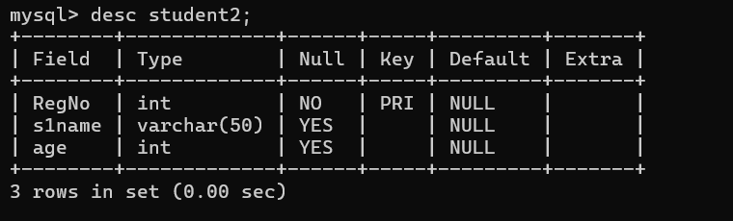
1) Alter the table STUDENT2.

2)Alter the table name FACULTY.
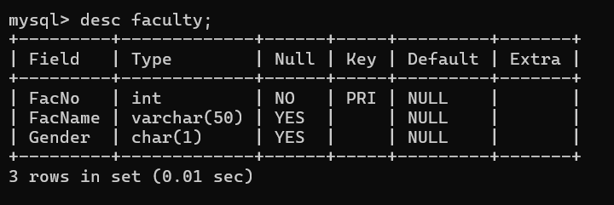
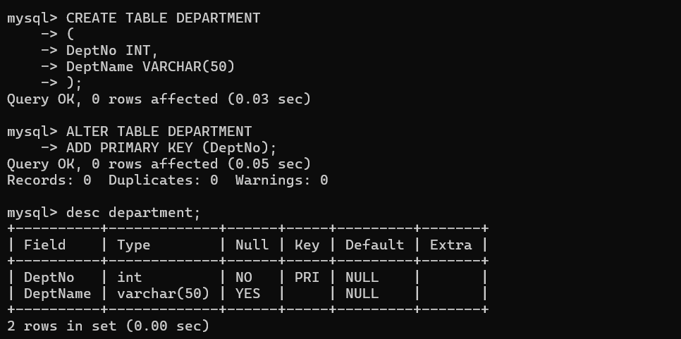
3. Alter the table name DEPARTMENT with following structure.

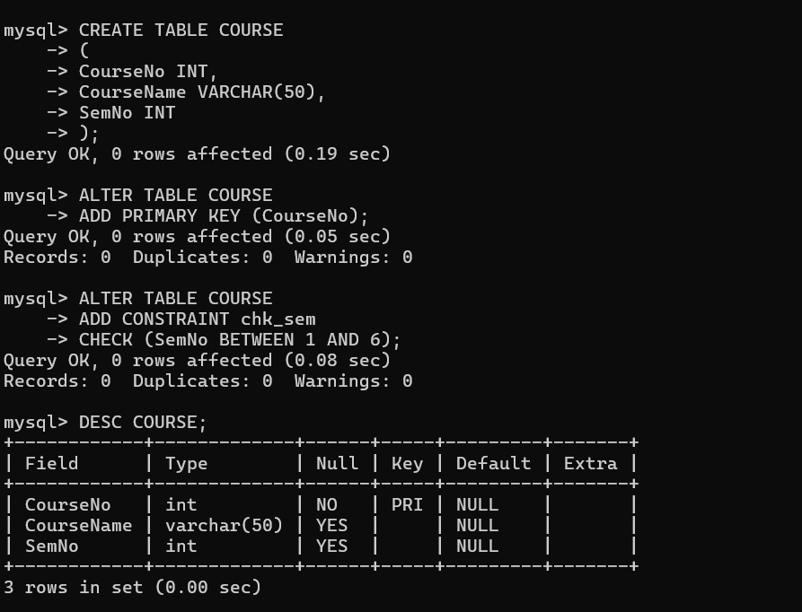
4. Alter the table name COURSE with following structure.

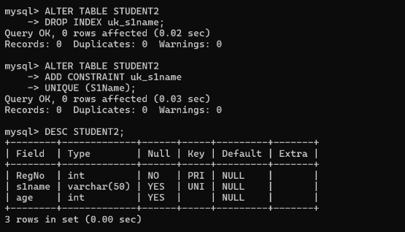
5. Alter the table name STUDENT2 with following structure.

6. After the STUDENT2 & STUDENT3 tables are successfully created, test if you can add a constraint FOREIGN KEY to the RegNo.
